**Python code with Django**

**Placement Prediction System**

**Steps:**

1. ***pip install Django***
2. ***cd E:***
3. ***cd Latha***

 (you can traverse to whichever location you want to create your project folder)

1. ***mkdir Placement*** (you can choose whatever name you want to use for your web application)
2. ***cd Placement_DjangoProject*** (cd into the folder you just created in the step above)
3. ***django-admin startproject Plcament_DjangoProject*** (this command will automatically create a django project with name Diabetic_Prediction_Web inside your main project folder)
4. ***cd Placement_DjangoProject*** (cd into the django project created in the step above)
5. Now if you followed the above steps correctly, just type in ***python manage.py runserver***into your command prompt screen and then copy the link that appear on the command prompt (<http://127.0.0.1:8000/>) into a web browser. As soon as you hit enter, you would be able to see the below screen

In PyCharm:

1. Create a folder templates
2. Then create home.html and predict.html files

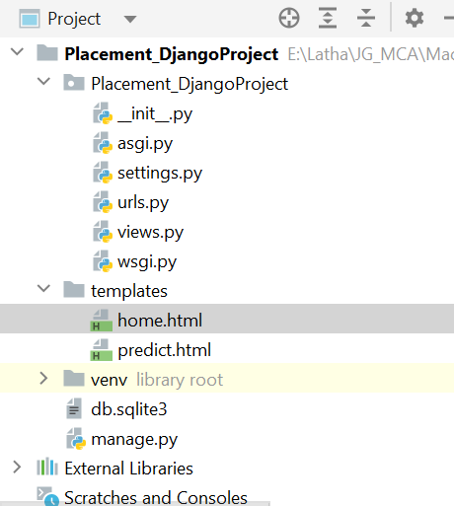

**Home.html**

<!DOCTYPE **html**>  
<**html lang="en"**>  
<**head**>  
 <**meta charset="UTF-8"**>  
 <**title**>Home</**title**>  
  
  
</**head**>  
<**body bgcolor="aqua"**>  
<**div align = 'center'**>  
 <**h1**>  
 WELCOME TO PLACEMENT PREDICTION SYSTEM</**H1**>  
  
 </**body**>  
</**html**>

**Urls.py**

**from** django.contrib **import** admin  
**from** django.urls **import** path  
**from** . **import** views  
  
urlpatterns = [  
 path(**'admin/'**, admin.site.urls),  
 path(**''**,views.home),

**views.py**

**from** django.shortcuts **import** render

**def** home(request):  
 **return** render(request, **'home.html'**)

**settings.py**

TEMPLATES = [  
 {  
 **'BACKEND'**: **'django.template.backends.django.DjangoTemplates'**,  
 **'DIRS'**: [os.path.join(BASE_DIR, **'templates'**)],  
 **'APP_DIRS'**: **True**,

**Execute the code:**

python manage.py runserver

<http://127.0.0.1:8000/>

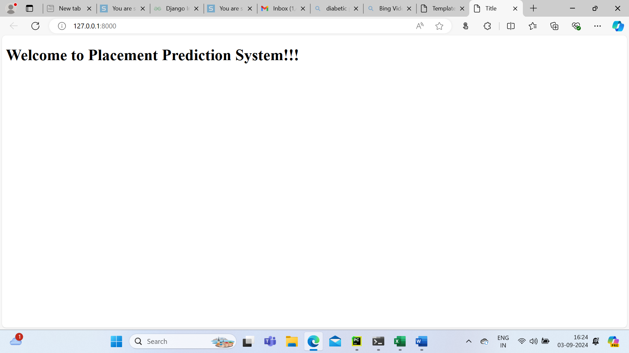

**Home.html**

<!DOCTYPE **html**>  
<**html lang="en"**>  
<**head**>  
 <**meta charset="UTF-8"**>  
 <**title**>Home</**title**>  
  
  
</**head**>  
<**body bgcolor="aqua"**>  
<**div align = 'center'**>  
 <**h1**>  
 WELCOME TO PLACEMENT PREDICTION SYSTEM</**H1**>  
  
 <**form action = "predict"**>  
 <**input type="submit" value="Let's get started"**>  
 </**form**>  
  
</**body**>  
</**html**>

**predict.html**

<!DOCTYPE **html**>  
<**html lang="en"**>  
<**head**>  
 <**meta charset="UTF-8"**>  
 <**title**>Title</**title**>  
</**head**>

<**body**>  
 <**h1**>Predict Page ...</**h1**>  
</**body**>

</**html**>

**Urls.py**

**from** django.contrib **import** admin  
**from** django.urls **import** path  
**from** . **import** views  
  
urlpatterns = [  
 path(**'admin/'**, admin.site.urls),  
 path(**''**,views.home),  
 path(**'predict/'**,views.predict),

**views.py**

**from** django.shortcuts **import** render  
  
**def** home(request):  
 **return** render(request, **"home.html"**)  
  
**def** predict(request):  
 **return** render(request, **'predict.html'**)

**Execute the code:**

python manage.py runserver

<http://127.0.0.1:8000/>

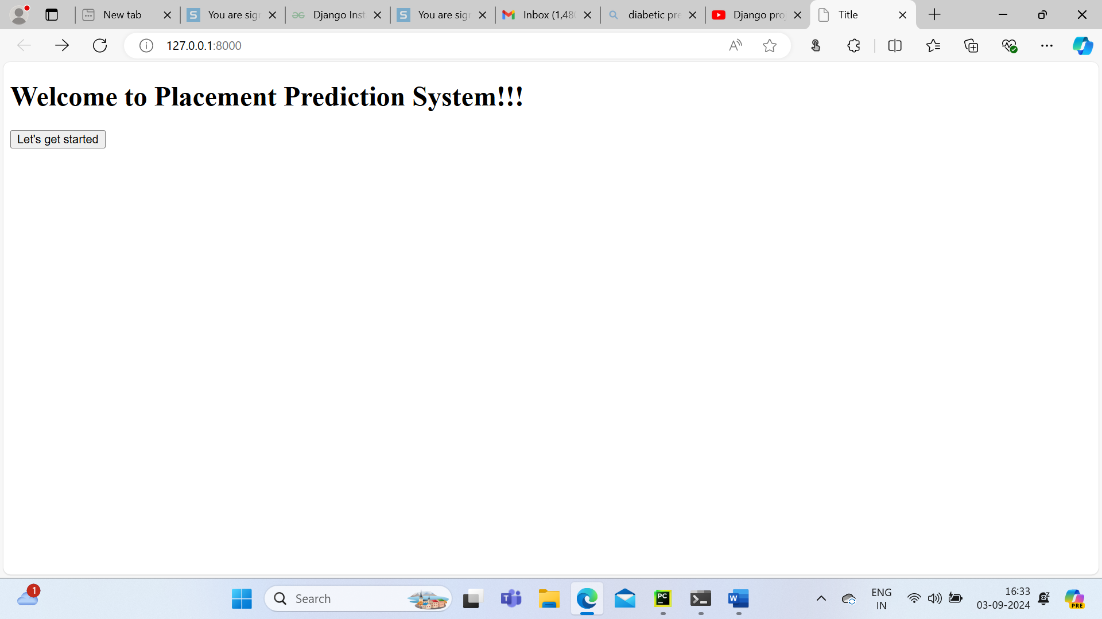

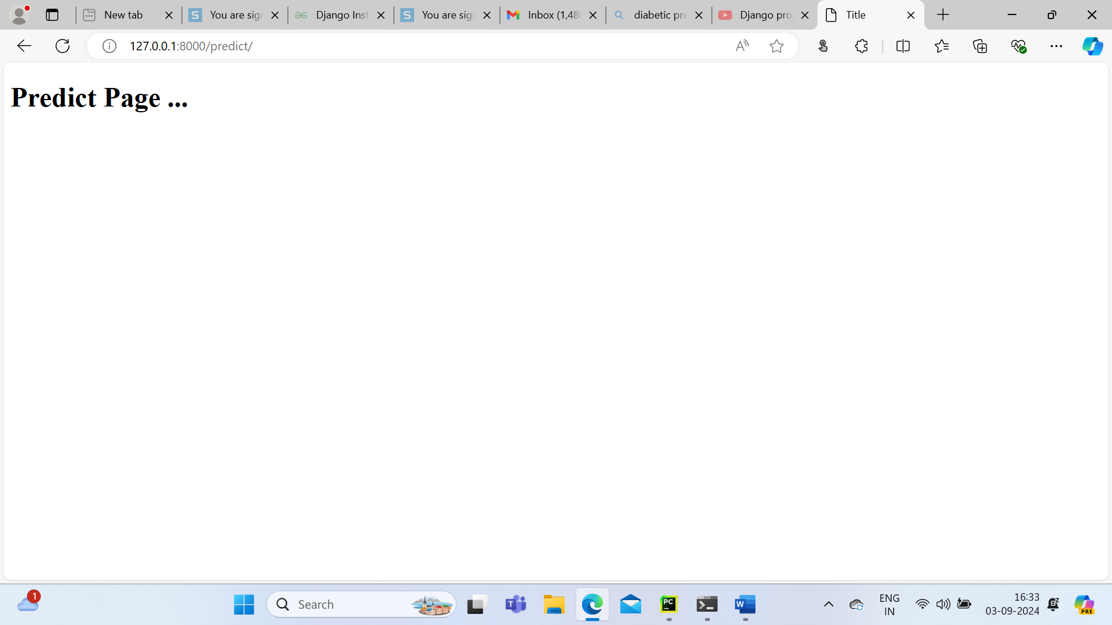

**predict.html**

<!DOCTYPE **html**>  
<**html lang="en"**>  
<**head**>  
 <**meta charset="UTF-8"**>  
 <**title**>Title</**title**>  
</**head**>  
<**body**>  
  
<**div style="color:coral;text-align:center";**><**H1**>Welcome to Placement Prediction Page</**H1**></**div**>  
<**div align="center"**>  
 <**h1**>Fill the following Data  
 </**h1**>  
 <**form action="result"**>  
 <**table cellspacing="5" cellpadding = "5"**>  
 <**tr**>  
 <**td align="right"**>Age</**td**>  
 <**td align="left"**><**input type="text" name="n1"**> </**td**>  
  
 </**tr**>  
  
 <**tr**>  
 <**td align="right"**>Gender </**td**>  
 <**td align="left"**><**input type="text" name="n2"**> </**td**>  
 <**td**> <**span class="title"**> Male: 0</**span**><**br**>  
 <**span class="title"**> Female: 1</**span**><**br**></**br**>  
 </**td**>  
 </**tr**>  
  
 <**tr**>  
 <**td align="right"**>Stream</**td**>  
 <**td align="left"**><**input type="text" name="n3"**> </**td**>  
 <**td**> <**span class="title"**> Electrical And Communication: 0</**span**><**br**>  
 <**span class="title"**> Computer Science: 1</**span**><**br**>  
 <**span class="title"**> Information Technology: 2</**span**><**br**>  
 <**span class="title"**> Mechanical: 3</**span**><**br**>  
 <**span class="title"**> Electrical: 4</**span**><**br**>  
 <**span class="title"**> Civil: 5</**span**><**br**> </**br**> <**br**>  
 </**td**>  
 </**tr**>  
  
 <**tr**>  
 <**td align="right"**>Internships</**td**>  
 <**td align="left"**><**input type="text" name="n4"**> </**td**>  
 <**td**><**span class="title"**>Yes: 1</**span**><**br**>  
 <**span class="title"**>No: 0</**span**><**br**>  
 </**td**>  
 </**tr**>  
  
 <**tr**>  
 <**td align="right"**>CGPA</**td**>  
 <**td align="left"**><**input type="text" name="n5"**> </**td**>  
 </**tr**>  
  
 <**tr**>  
 <**td align="right"**>Hostal</**td**>  
 <**td align="left"**><**input type="text" name="n6"**> </**td**>  
 <**td**><**span class="title"**>Hostel Live: 1</**span**><**br**>  
 <**span class="title"**>Hostel Not Live: 0</**span**><**br**>  
 </**td**>  
 </**tr**>  
  
 <**tr**>  
 <**td align="right"**>History of Backlog</**td**>  
 <**td align="left"**><**input type="text" name="n7"**> </**td**>  
 <**td**><**span class="title"**>Yes: 1</**span**><**br**>  
 <**span class="title"**>No: 0</**span**><**br**>  
 </**td**>  
 </**tr**>  
  
 </**table**>  
 <**input type="submit"**>  
 </**form**>  
 <**br**>  
  
 Placement Prediction Result: <**br**> <**br**><**div style="color:Blue; font-weight:bold;"**>{{result2}}  
 </**div**>  
</**div**>  
</**body**>  
</**html**>

**views.py**

**from** urllib **import** request  
  
**from** django.shortcuts **import** render  
  
**import** pandas **as** pd  
**import** numpy **as** np  
  
**from** sklearn.model_selection **import** train_test_split  
**from** sklearn.preprocessing **import** MinMaxScaler  
**from** sklearn.linear_model **import** LogisticRegression  
**from** sklearn.metrics **import** accuracy_score  
  
**def** home(request):  
 **return** render(request, **"home.html"**)  
  
**def** predict(request):  
 **return** render(request, **'predict.html'**)  
  
**def** result(request):  
 dataset = pd.read_csv(**r"E:\\Latha\\JG_MCA\\MachineLearning\\Placement\\collegePlace.csv"**, encoding=**'latin-1'**)  
  
 **"""dataset['gender'].replace({'Male': 0, 'Female': 1}, inplace=True)  
 dataset['Stream'].replace({'Electronics And Communication': 0,'Computer Science': 1,'Information Technology': 2,'Mechanical': 3, 'Electrical': 4,'Civil': 5}, inplace=True)  
"""** *# selecting the features and labels* Y = dataset[**"PlacedOrNot"**]  
 X = dataset.drop([**"PlacedOrNot"**], axis=1)  
  
 **from** sklearn.model_selection **import** train_test_split  
  
 X_train, X_test, Y_train, Y_test = train_test_split(X, Y, test_size=0.2)  
  
 *# creating a classifier using sklearn* **from** sklearn.linear_model **import** LogisticRegression  
  
 model = LogisticRegression(random_state=0, max_iter=1000).fit(X_train, Y_train)  
  
 val1 = float(request.GET[**'n1'**])  
 val2 = float(request.GET[**'n2'**])  
 val3 = float(request.GET[**'n3'**])  
 val4 = float(request.GET[**'n4'**])  
 val5 = float(request.GET[**'n5'**])  
 val6 = float(request.GET[**'n6'**])  
 val7 = float(request.GET[**'n7'**])  
  
 pred = model.predict([[val1, val2, val3, val4, val5, val6, val7]])  
  
 result1 = **""  
 if** pred == [0]:  
 result1 = **"You are not Placed ... "  
 else**:  
 result1 = **"Congratulations !!! You are Placed !!!"  
  
 return** render(request,**"predict.html"**,{**"result2"**:result1})  
  
**Urls.py**

**from django import views  
from django.contrib import admin  
from django.urls import path  
from . import views  
  
urlpatterns = [  
 path('admin/', admin.site.urls),  
 path("",views.home),  
 path('predict/', views.predict),  
 path('predict/result',views.result),  
]**

